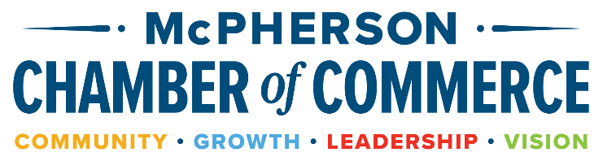

ANNUAL SPONSORSHIP LEVEL OPPORTUNITIES

PLEASE RETURN THIS FORM BY SEPTEMBER 1st to 306 N. Main, McPherson 67460 if you choose to be a Chamber sponsor. We are happy to answer questions or discuss other ways your business may be involved. Contact us at 620-241-3303. Thank you for supporting the McPherson Chamber. We appreciate you!
Company Name: _____________________________________________ Phone: ________________________________

Contact Person: ______________________________________________ Email: ________________________________

Sponsor Level you wish to support: ____________________________________________________________________

 | ELITE | CATALYST | IMPACT | COMMUNITY
ANNUAL BENEFITS | $3500 | $1000 | $350 | $100
Enrollment for one in Leadership McPherson class of 2026 | X
Event Sponsor status at 2026 Chamber Classic Golf Tournament, includes 1 free golf team | X  ($1500 value)
Chamber Connections sponsor**  (Reaches over 2000 attendees per year!) | X
Company logo on Sponsor banner* | X | X
Company logo on all Chamber e-newsletters (Reaches 1600 inboxes EVERY week!) | X | X
Logo on Chamber website homepage | X | X
Chamber Annual Meeting – reserved table for 6 | X | X
e-Newsletter- article/business spotlight | 4/year | 2/year | 1/year
Logo displayed on annual meeting slideshow | X | X | X
Online directory enhanced listing | X | X | X | X
Category Sponsors: Leadership, Entrepreneur, Civic Awareness, & Professional Development | All 4 included  ($400 value) | All 4 included  ($400 value) | Pick 2  ($200 value) | Pick 1  ($100 value)
*Banner displayed at every event such as candidate forums, legislative coffee, youth entrepreneurship challenge, and annual meeting etc. (Will not be displayed at Chamber Connections or Ribbon Cuttings)

**Company logo displayed at every Chamber Connection event and recognition during Chamber Check prize drawing.

CATEGORY SPONSORS – All 4 are included for Catalyst and Elite or Pick 2 for Impact Sponsors or 1 for Community Sponsors
Sponsors for each category below will receive: Company logo displayed at category-related events (does not include Chamber Connections) and sponsorship acknowledgment in e-newsletter and website.

____ LEADERSHIP MCPHERSON – Promote leadership capacity that inspires visionary, positive action to motivate and strengthen our community.

____ ENTREPRENEUR – Encourage business development, entrepreneurial endeavors, and programs like the Youth Entrepreneurship Challenge.

____ CIVIC AWARENESS – Support an informed voting population in McPherson County through the Chamber’s candidate forums and legislative updates.

____ PROFESSIONAL DEVELOPMENT – Champion lifelong learning by sponsoring one or more professional development speakers to inspire businesspeople in our community. Topics may vary.

